Abstract
Time-to-event and Survival Analysis is a cornerstone of epidemiological research, classically completed through statistical modeling approaches. The recent advances in machine learning over the last decade has led to the development of novel methods that often outperform the classical statical modeling approaches when the underlying data is complex. Bayesian Additive Regression Trees (BART) is one such machine learning algorithm that has recently been extended to the Survival Analysis setting [1,2]. In this current study we created a novel Survival Analyses algorithm, built on top of a generic BART implementation within probabilistic programing language PYMC [3,4]. Our algorithms performance was examined in a variety of Survival settings with varying complexity, with comparisons made against the commonly used statistical modelling approaches (Kaplain-Meier and Cox-Proportional Hazard Models)[5] and to a previously developed Time-To-Event BART algorithm[2]. In this paper we provide an introduction to the baseline BART algorithm, followed by an overview to our algorithm. We then demonstrate the performance of our algorithm through a series of simulation studies and provide discussion on the benefits and limitations to our approach.

Introduction
Survival Analysis is a class of analyses focused on fitting a model to the latent probability that an event has not occurred for an observation by a certain timepoint. This class of analyses is commonly used in epidemiological studies using statistical modeling approaches like the non-parametric KM (find the other name for this) and the semi-parametric Cox Proportional Hazard Model (CPH) or other fully-parametric modeling approaches. While these classical methods have been successfully employed to support research initiatives in the past, they can suffer from limitations when trying to identify variable effects in complex Survival settings [7]. More recently focus has been placed on developing fully non-parametric Survival Analysis approaches that aim to remove the constraints associated with the classical modeling approaches. This new set of methods relies heavily on extension of foundational machine learning algorithms, with successful implementations that can be found that use Neural Networks and sum-of-tree based such as XGBOOST, Random Forest and the focus in this work: Bayesian Additive Regression Trees [8].

BART
Bayesian Additive Regression Trees (BART) is an ensemble Machine Learning algorithm that utilizes a sum of regression trees approach to derive a model of the functional relationship between an outcome and set of predictors. While it is similar to the other ensemble tree methods on baseline characteristics, BART is characterized by major differences due to its underlying Bayesian probabilistic framework used to develop the collection of regression trees.

Briefly, to summarize the primary BART algorithm. The algorithm starts with an initialization of the priors for the individual trees and splitting criteria. A set of trees are initialized starting with their root node. Through successive iterations a change to each tree is proposed and each proposal is accepted or rejected based on the likelihood of the proposed tree. Additionally, a mean value of the outcome is set to the leaf nodes by passing the observed data through the set of trees and taking the mean value of the outcome from the observations that fall within each leaf node. DON’T FORGET THE RESIDUAL. Through this iterative process the accepted tree sets are collected as the posterior distribution of regression trees. Posterior predictive distributions for the outcome can be collected by again passing the observation through all collected tree-sets in the posterior and returning the sum of node values for observations across all trees. This returns a posterior predictive distributions for each observation from which credible intervals and point estimates of values can be obtained. A deeper review of the BART algorithm can be found in the original BART paper and from papers from other implementations of the algorithm [1,2, 9,10].

The BART algorithm has several properties that allows it to be successfully used in practice (rephrase). The BART priors on the individual trees repress the depth of the trees, creating individual weak learners of each tree, that in aggregation represent the underlying function without much issue in overfitting. FIND THE OTHER BART REVIEW STUF [1,2,910,11].

BART was initial designed to model continuous outcomes, but extensions to binary and other outcomes have additionally established. This includes extensions to Survival Analysis completed by Sparapani et. al which follows a discrete time-to-event approach in which the observation time outcome is modeled as a binary outcome given as the probability of the event occurrence at distinct times over the set of observed event times. This initial BART Survival algorithm maintained the performance characteristics associated with the original BART algorithms and displayed advantages over both the classical statistical models and other non-parametric Machine Learning for Survival Analyses algorithms. [2,10,12]

PYMC is a probabilistic programing language (PPL) built within the python programming language. As a PPL it boasts a powerful API for constructing and implementing Bayesian models through a robust and rigorous framework. [4]. Recently PYMC developers introduced their on BART algorithm, which can easily be incorporated into the PYMC modeling framework. To our knowledge this is the only well maintained BART algorithm available in the python programming language. While conceptually similar to foundational BART algorithms, PYMC-BART employs an alternative sampling algorithm where a full set of trees is grown at each sampling step rather than partial adjustment.
REVIEW THIS AGAIN
For deeper review of the Particle Gibbs sampler and the PYMC-BART algorithm refer to [4,11].

BART-Survival Algorithm

In our work we use logic from Sparapani’s BART Survival algorithm in combination with the BART algorithm implemented in the PYMC library. Our algorithm and associated library provides a ready-to-use BART Survival algorithm and independent package which will allow practitioners implement the method when python is the preferred programming language or the R programming language (used in Sparapanis algorithm, I think the comment about R is earlier) is not available.[3,4] Our algorithm has two primary components: the data augmentation step and the BART modeling step.

Data Augmentation

Survival datasets are typically include the variables: event status, time of event, set of covariates for each observation. In discrete time survival analysis the observations are expanded on a grid of the event times, with the time added as a variable to the covariate matrix. To complete this augmentation, first an ordered set of unique event times is collected from the observed event times, denoted as P. For a single observation, a set of times Q is generated that includes the values from P up to and including the time of event for the observation and the length of the set Q is established as k. The single observation is then expanded to an augmented matrix A, which is the length of k observations and includes the augmented outcome E, the time column Q and the replicated covariate set V. The augmented outcome E equals 0 for all rows in A less than k and row k is set to the (0,1) value from the original event status variable for the observation. This process is repeated for each observation resulting in the full augmented matrix A* where E* is the outcome, and Q*, V* combined are the covariates for the model.

A* provides the necessary data to train the model, a secondary dataset A+ is also needed to retrieve estimates at each time in P for each patient. Simply A+ is a grid-expansion for each patient with the vector P time points and a replicate vector of the covariates of length P.
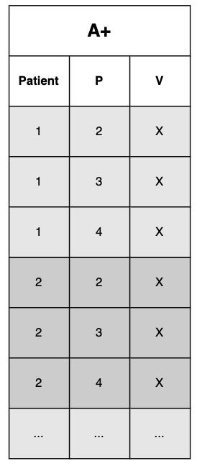
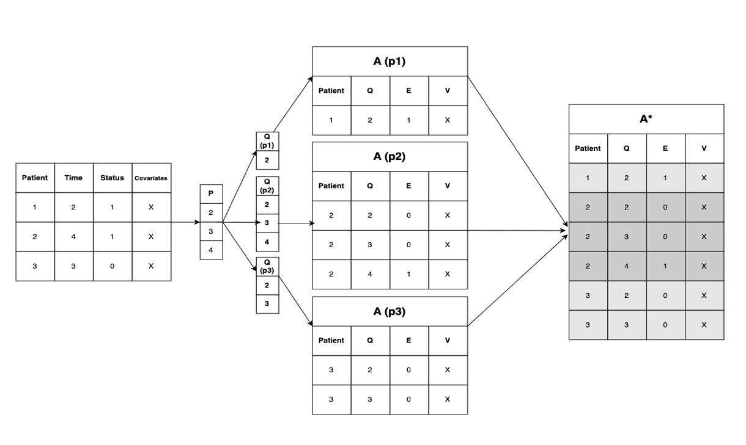
Figure 1
Training Data Augmentation procedure
Predictive Dataset A+

Modeling:
The BART Survival model using the augmented matrix A* is conceptually similar to a probit linear regression of the binary event outcome over the rows of A for each patient. The resulting model provides estimates of the probability of the outcome occurrence in the interval for each discrete time in Q. In the BART Survival model, the linear regression is replaced by the nonparametric BART random variable from which the posterior estimates of the probability of the outcome at each time can be modeled.

More formally the model is described for each observation set A_i, from which
y_ij = E_j, where i denotes the observation set and j denotes the time index.

then;

y_ij|p_ij ~ Bernoulli(pij)
p_ij | f ~ \invprobit(mu_0 + f)
f ~ BART(Y|t_ij, V_ij)

The likelihood is …. Find

To obtain the survival estimates across the timepoints in P, first a prediction matrix is obtained through inference on the prediction dataset A+, which returns a probability estimate for each timepoint for each patient Then taking the estimates as a discrete hazard rate, the probability of survival can be obtained using the formula:

S(p) = 1-Cumsum(ln(p)). EXPAND

To derive inference from the model, marginal effects can be determined using Friedman Partial Dependency Function. EXPAND [cite]

Methods

We evaluated our algorithm over a series of simulation studies the varied in the survival setting complexity with comparisons made to the R based BART Survival algorithm and to other appropriate statistical models.

Baseline Simulation

Low Complexity 1.

To establish basic validity of the method we evaluated the method in two baseline settings. The baseline settings survival distributions were simulated using a Weibull function S(t) = exp(-t/scale)^shape.

Low Complexity Simulation 1
The first setting was simulated with draws from a single survival distribution with scale=7 and shape=3. Censoring was incorporated through independent draws from an Exponential distribution, parameterized to reach 20% and 50% total censoring. The setting was evaluated with sample sizes of N=200,400 and the Survival distribution was evaluated at the 10th, 25th, 50th, 75th, and 90th percentiles. 100 iterations of the single sample setting were simulated and metrics were averaged over these iterations across the combination of settings (censoring (2), N(2), percentiles(5)) resulting in 20 distinct metric measures. Metrics used include Coverage Probability, RMSE and Bias. Our BART survival algorithm was evaluated against the Kaplan-Meyer estimator and the previously developed BART survival algorithm by Sparapani (p-BART, KM and r-BART respectively), with comparisons made between the point estimates, taken as the mean of the posterior distribution of both the p-BART and r-BART methods (for RMSE and Bias) and the 95% uncertainty intervals collected as credible intervals of the 2.5% and 97.5% percentiles of the posterior distribution (for the p-BART and r-BART methods, and as standard confidence intervals for the KM estimator. Our algorithm, p-BART, is comparable across all three metrics to both the KM and r-BART methods in the simple, single sample simulation. RMSE is nearly equivalent between the three methods and the p-BART bias has a slightly larger spread of values than the KM and r-BART. The coverage probability displays p-BART is over-obtaining the optimal coverage in comparison to the other methods. Of note here, is that the spread (variance) of the posterior distribution within the p-BART method is affected more heavily by the number of trees parameter used, with increasing the number of trees leading to decreased variance of the posterior. We evaluate this number of trees parameter setting and other settings in the parameter section.

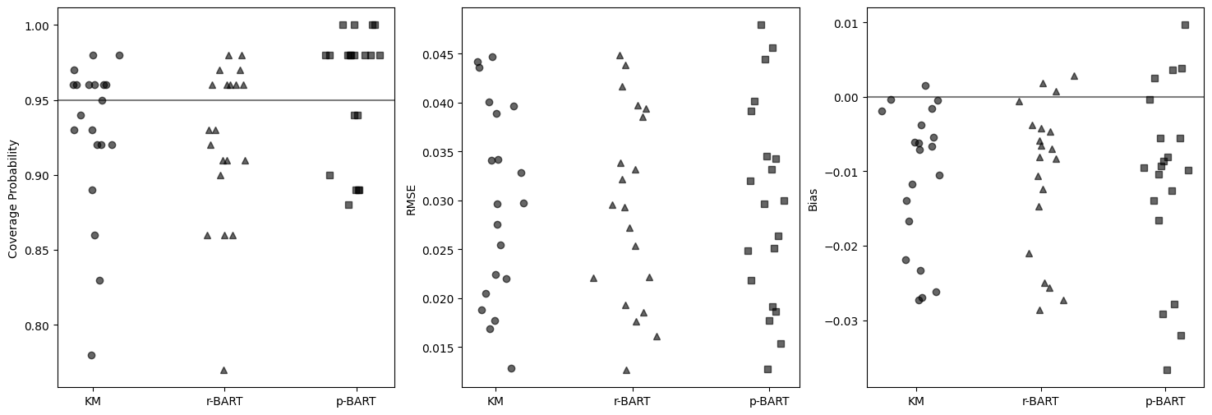
Figure 1
Coverage Probability, RMSE and Bias for simulation settings of scenario 1.
One Sample
N = [200, 400], percentiles = [0.1,0.25,0.5, 0.75,0.9], iterations/simulation 100

Low Complexity Simulation 2
The second low complexity setting involved simulations from two sample survival distributions generated from Weibull distribution with parameters: scale=12, shape=1.2 and scale=11.5, shape=2, connected by a single binary covariate. The p-BART algorithm was assessed along with the r-BART and KM estimates. The p-BART and r-BART algorithms employed regression on the single covariate to estimate the two distinct distributions, the KM estimates were obtained through stratification on the single covariate. The simulation was evaluated with the settings n=200,400, with censoring introduced through independent draws from an exponential distribution parameterized to achieve censoring of 20% and 50%. Each combination of settings was evaluated over 200 simulated datasets. Survival estimates were evaluated at the 10th, 25th, 50th, 75th, and 90th percentiles. RMSE, Bias, and Coverage Probability were derived for each sample distribution independently and subsequently averaged together to summarize within each setting/percentile. Results are shown in Figure 2.

Our p-BART algorithm performs similar to the KM and r-BART in regards to RMSE and Bias, with some notable added dispersion among the p-BART among a few of the settings evaluated. This dispersion is similarly displayed in the Coverage Probability measure, with four of the evaluated settings dropping far below nominal coverage. Further description of these results can be found in Appendix A.
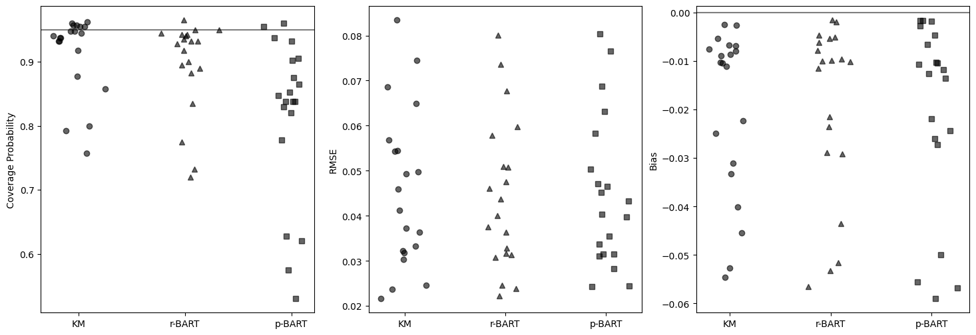
Figure 2. (iter = 200) this is the better one
Coverage Probability, RMSE and BIAS for the simulation settings of scenario 2
Two Sample
N = [200, 400], percentiles = [0.1,0.25,0.5,0.75,0.9], iterations/simulation=200
Metrics from the two samples averaged together for each simulation setting.

Regression Scenarios

To examine our BART Survival algorithm performance in more practical scenarios we simulated two regression scenarios and conducted evaluations with our p-BART algorithm, the r-BART algorithm and a Cox-Proportional Hazard Model (CPHM) for comparison. Cox Proportional Hazard Models are a common semi-parametric modeling approach commonly used in Survival analyses. They benefit from the semi-parametric structure, being able accommodate a broad variety of survival distributions. However, their flexibility only extends to situations where the hazards are proportional over the observations. When the underlying distribution fails to follow a proportional hazard assumption the CPHM produces inaccurate results.
We evaluate our model in both proportional and non-proportional hazard settings using a simulation with nine binary covariates, each having 0.5 probability. Seven of the covariates were set to contribute to the Survival function through the generating Weibull function employed in the simulations. When the covariates contribute through the scale parameter alone the generated distribution remains proportional and when the contribution is made through both the scale and shape parameters, the resulting distributions are non-proportional. The two remaining covariates were included in the training data as noise factors. The scale and shape parameters used in the proportional and non-proportional settings are as follows:

PH:
scale=np.exp(3 + 0.1*(x_mat[:,0] + x_mat[:,1] + x_mat[:,2] + x_mat[:,3] + x_mat[:,4] + x_mat[:,5]) + x_mat[:,6])
shape = 2
NPH:
Scale = 20 + 5*(x_mat[:,0] + x_mat[:,1] + x_mat[:,2] + x_mat[:,3] + x_mat[:,4] + x_mat[:,5] + 10*x_mat[:,6])
Shape=0.7 + 1.3*x_mat[:,6]

The evaluation was completed with 200 simulations of each Proportional/Non-proportional settings, with sample size N=400 and censoring introduced with draws from an Exponential distribution, parameterized to reach 20% censoring in each scenario. The trained models were evaluated through RMSE and Bias collected at the 90th, 75th, 50th, 25th and 10th percentiles of the total distribution times. The results are characterized as boxplots in figure 3 below. In the proportional hazard settings, both the BART models perform similar to CPHM, with CPHM displaying a slightly better performance in both the RMSE and Bias measures. In the non-proportional setting the BART models outperforms CPHM by a notable margin on RMSE. The bias is the non-proportional setting displays no notable differentiation.

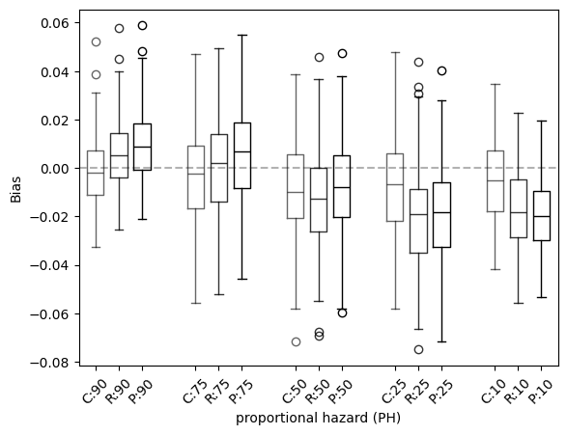
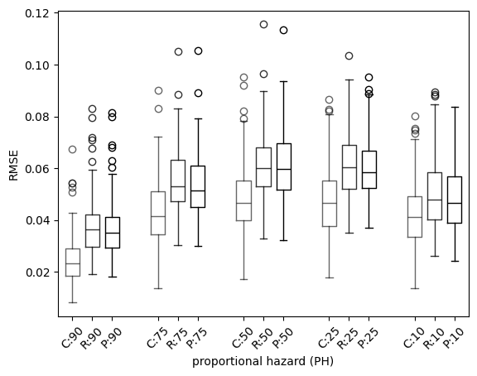
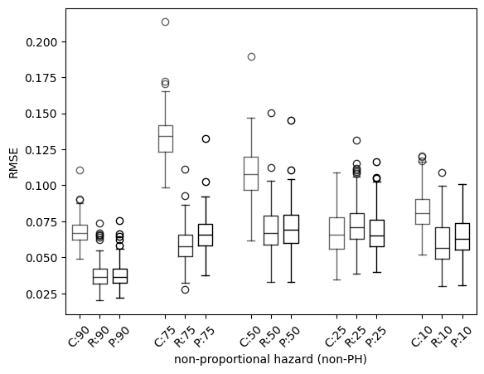
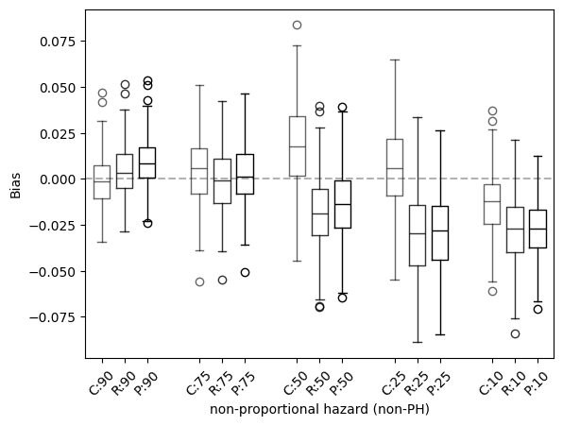
Figure 3.
Boxplot for RMSE and Bias for regressions for both proportional and non-proportional scenarios. Esitmation methods using Cox-Proportional Hazard models, r-BART and p-BART (C,R,P) measured at the 90th,75th,50th,25th,10th percentiles of total survival time.

Complex Regression
Further evaluation of our algorithm’s predictive performance was completed with simulations in a complex regression setting. Each observation was generated with 10 continuous covariates, each drawn from a uniform distribution in the range 0 to 1. A Weibull distribution was used to generate survival times, parameterized with the following scale and shape configurations designed to introduce complexity in the regression scenario to evaluate our algorithms to accommodate complex settings.

Scale = "np.exp(3 + 0.5*np.sin(np.pi * x_mat[:,0] * x_mat[:,1]) + np.power((x_mat[:,2]-0.5), 2) + 0.5* x_mat[:,3] + 0.25 * x_mat[:,4])"

Shape = 2

Of the 10 covariates created, 5 were included in the scale parameter generating function. The remaining 5 covariates were included as noise in training dataset. Datasets of sizes N=400,1000,4000 were generated and a corresponding test dataset was generated for each respective size, N. Censoring was introduced using an Exponential distribution, parameterized to reach 20% censoring in each dataset. For each N, a p-BART was trained and predictions collected for testing dataset at the 90th, 80th, 70th, 60th,50th, 40th, 30th, 20th and 10th percentiles of the overall survival time. Evaluation of the models were derived through comparison of the predicted and simulated survival probabilities. Scatter plots of the predicted versus simulated survival probabilities are displayed in Figure 4 along with R-squared and median absolute error values. For all values of N (400,1000,4000) the plots display an appropriate spread around the identity line which constricts accordingly with increase of sample size. These results indicate our BART survival algorithm performs considerably well in complex regression settings.

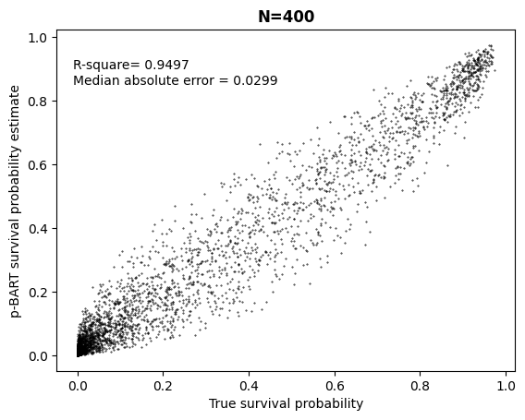
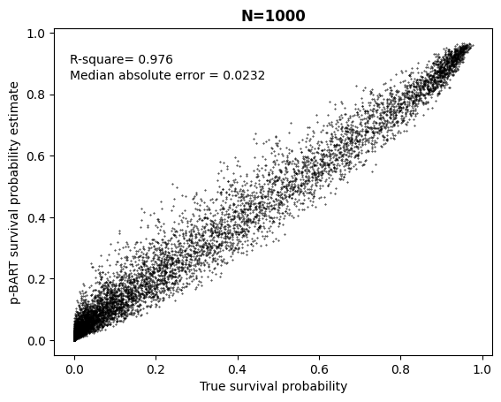
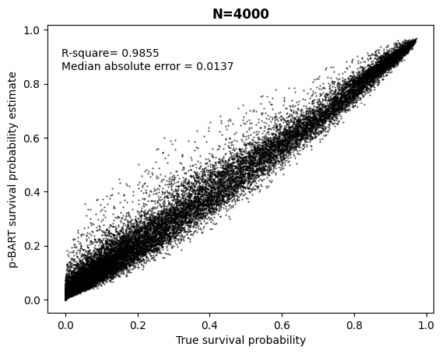
Figure 4.
Complex continuous regression trained on sample size N=400,1000,4000 and evaluated on test sets 400,1000,4000 respectively. R-squared and Median absolute error calculated for each test set.

PYMC-BART Parameter Evaluation

The baseline PYMC-BART algorithm that serves as the foundational algorithm to our p-BART survival algorithm has several parameters that can be considered for adjustment to enhance model performance in various setting (list a few of these parameters). We evaluate our algorithm over adjustments to the number of trees: (25, 50, 100, 200), number of tuning steps: (100,1000) and number of draws collected: (500,1000,2000). Number of trees was selected for further review do to its association with model fit and performance. The number of tune and draw steps were selected for further evaluation because of the overall computational complexity and computation time for the BART algorithm. Specifically, providing an estimate of minimum number of tune and draw step required for sufficient performance is useful for maximizing computational efficiency.
A single simulation scenario of 1000 observations, each with 10 covariates, of which 2 covariates being binary [0,1] with equal (0.5) probability of occurrence and 8 continuous covariates drawn from a uniform distribution in the range 0 to 1. Survival times were simulated from a Weibull distribution parameterized with the following scale and shape parameters and no censoring was incorporated in the dataset.

'scale_f': '20 + 4*x_mat[:,0] + 5*x_mat[:,1] + (1.4*x_mat[:,2])**2 - 2*x_mat[:,3]*x_mat[:,4]',
'shape_f': '1.6 + 1.2 * x_mat[:,0]

The dataset was utilized for training each combination of adjustment parameters (trees, train, tune) and the trained model was evaluated using a secondary test dataset of the same specifications. Each model was evaluated with RMSE, bias, credible interval width and proportion of prediction interval coverage, averaged across the 90th, 75th, 50th, 25th and 10th percentiles of the total survival time.

Evaluation of the parameters display few notable takeaways. Adjusting the number of trees provides the largest difference in outcomes in regards to RMSE, with both too few and too high of number of trees leading to worst performance assumed to be due to underfitting and overfitting of the training data at the 25 and 200 trees settings. RMSE was also impacted by the number of tuning steps, with increasing tuning steps from 100 to 1000 steps leading to a decrease in RMSE. Similarly, increasing the tuning steps demonstrated a large impact on the 95% credible interval width. The proportion of predictive interval coverage was fairly resilient to parameter changes, with number trees being < 50 leading to the worst predictive interval coverage. Bias was mostly unaffected by any of the parameterizations.

The results from various parameterizations does not clearly illuminate a precise recommendation for parameterization but a few takeaways could be suggested. First number of trees between 50-100 appears to be optimal across all metrics. Second, number of tune steps of 1000 leads to more narrow credible intervals, without significant loss in predictive coverage proportions or RMSE and Bias. Number of draws of 1000, appears to not return significantly different results than the 2000 draw settings and could be an optimal setting when the computational burden becomes too large. A table of the parameterization results can be found in the appendix.
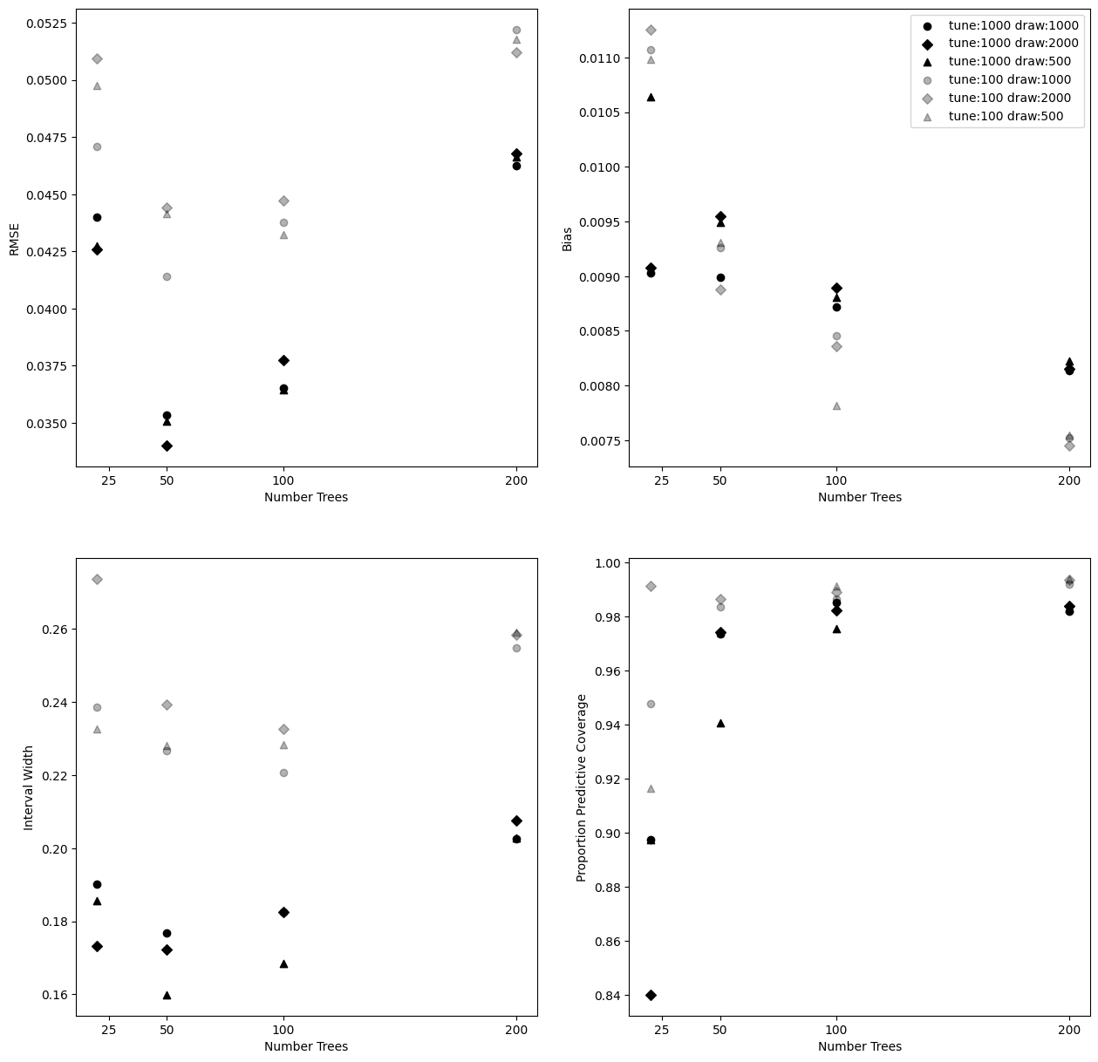
Figure 5.
RMSE, bias, credible interval width and proportion predictive interval coverage for the varied parameter settings. Number of trees = (25, 50,100,200) captured on all x axes, number of tune steps=(100,1000) differentiated by colors (grey, black) and number of draws (500,1000,2000) differentiated by shapes (triangle, circle, diamond).

Discussion

Through the simulations studies we have demonstrated that our BART Survival algorithm is an appropriate and useful approach for completing time to event analyses. Our survival analyses algorithm as an extension of the general PYMC-BART algorithm maintains its capabilities as an adaptable, function-finding algorithm, proficient in identifying interactions and non-linearities within the data. Additionally, in the context of survival analyses, our BART-Survival algorithm requires no added distributional assumptions, allowing it to be performative in non-proportional settings without added analytic work.

While similar methodologies exist for employing the BART in the survival analyses setting, these methods have only been constructed for R programming language analytics. As far as we are aware, this package is the first that makes a BART-Survival algorithm available in the python programming language. Our algorithm is directly dependent on the base PYMC-BART and PYMC libraries, with our core algorithm being a pre-specified PYMC model which incorporates the BART random variable. While this pre-specified model is not terribly complex to implement, our library and package is designed to abstract away the PYMC architecture from the users, allowing for a simpler implementation of the analyses akin to other survival analyses packages (lifelines, scikit-survival). Our package additionally provides succinct utility functions required to configure the data for the analyses and functions to complete partial dependence analyses in a survival-time respective format. While our library provides a convenient API to complete analyses, the core PYMC components are exposable to the user, providing access to the core PYMC, PYMC-BART functionalities, which can be useful for evaluating the sampling process or computing variable importance measures beyond simple variable inclusion rankings.

Across our simulation studies, our algorithm performed nearly equivalent to the r-BART algorithm [cite]. We include the r-BART algorithm more as a baseline benchmark rather than a performance competitor. Given our p-BART-Survival algorithms successful performance we recommend our package to users who may want to have access to the powerful BART algorithm, but either prefer or are restricted to using the python programing language. We additionally made comparisons to the Cox Proportional Hazard Model algorithm, which is commonly employed for survival analyses. Through our simulation studies we demonstrate that our algorithm demonstrates improved performance in the non-proportional hazard setting and maintains near similar performance to the Cox models in the proportional setting.

One limitation of BART is the high computational burden/efficiency associated with the algorithm. This issue is specially prominent in our BART-Survival algorithm for two reasons. First the core PYMC-BART algorithm is implemented in pure python, whereas the r-BART implementation incorporates C++ to improve computational efficiency. There is some work being completed in implementing BART in a faster programming language, but these modules are not currently available from the core PYMC-BART library. We are exploring our abilities to contribute to the development of a more efficient algorithm for future work.

The second major speed impediment for the BART-Survival algorithm comes from the grid-time expansion, where the dataset size blooms from N observations to N*T observations, where T is the number of distinct time-points. To reduce the impact of the grid-time expansion, it is recommended to coarsen the observed outcome times to a reduced set of distinct time-points (ie 365 days can be coarsened to 52 weeks, 12 months or 4 quarters). While coarsening results in loss of information between discrete time-points and increase in the number of tied outcomes, there is no information loss at the distinct time-points at which the dataset is coarsened too, allowing coarsening to be an appropriate solution when the outcome of interest is survival/hazard at a single or multiple distinct time points rather than the need for a smoother survival curve. Other BART-survival models exist that do not depend on the discrete-time expansion {cite}. These models again only exist in the R programing language and we are considering implementing such models within our python/PYMC framework to increase their availability.

In our study we conducted only a limited number of simulation experiments and compared only a few alternative modeling approaches. There are other statistical and machine learning approaches to survival/time-to-event analyses that would be worth completing comparative analysis against in future work [find a analyses comparison study]. However, many of these approaches from the machine learning (survival-random forest, …) are not designed for statistical estimation, making effect estimates such as single-time point survival probability difference or marginal hazard ratios/risk ratios, along with their quantification of uncertainty, non-achievable without application of additional statistical methods [cite targeted learning]. BART has an advantage in this regard as the posterior distributions achieved through the sampling algorithm provide natural quantification of uncertainty and easy derivation of effect estimates. BART based approaches also have an added advantage in while being computationally slower than other non-bayesian machine learning approaches, it is typically allows a one-shot approach to modeling, as the out-of-the-box parameters are often sufficient for training a sufficient BART model. In comparsion other ML or statistical models require the additional analytic time-costs in employing cross-validation or custom model specification.

Finally, in our supplementary materials we have attached an introduction to our BART-Survival package, which is available through PIP [expand]. This introduction provides overview of the data preparation, survival modeling and common effect estimation through marginal dependence functions provided by our python library.

Bibliography

- Friedman OG BART
- Sparapani Survival
- PYMC BART paper
- PYMC general citation
- Maybe site the KM and CPH approaches
- Employment of survival analyses in public health settings
- Need a citation about limitations of CPH
- Need citation for general ML methods for Survival (NN, XGBOOST, RF, SVM)
- Other BART review papers
- Sparapani BART general
- Particle gibbs lakish…
- Citation for BART vs ML methods (I have this somewhere)

